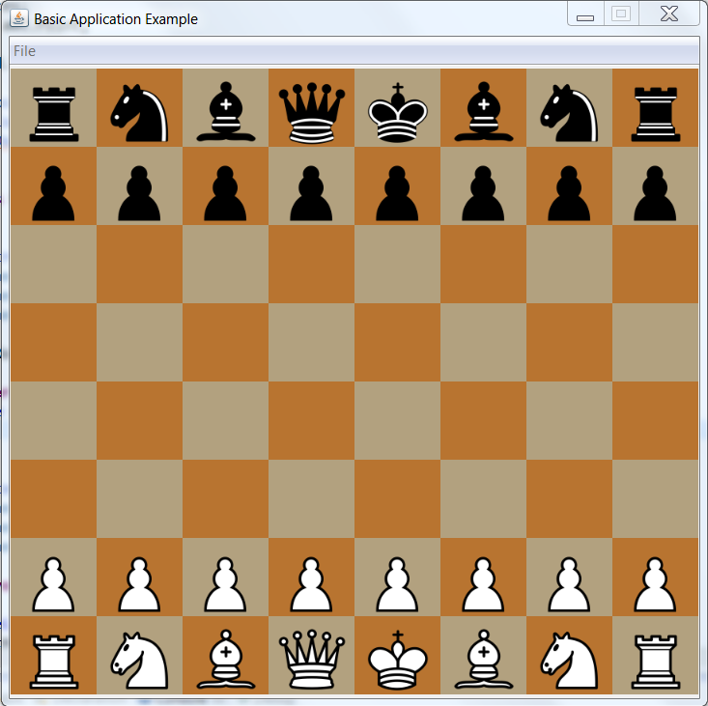

Step 1: Open the Gui.java file and run it. The GUI that is generated should look like the above picture.

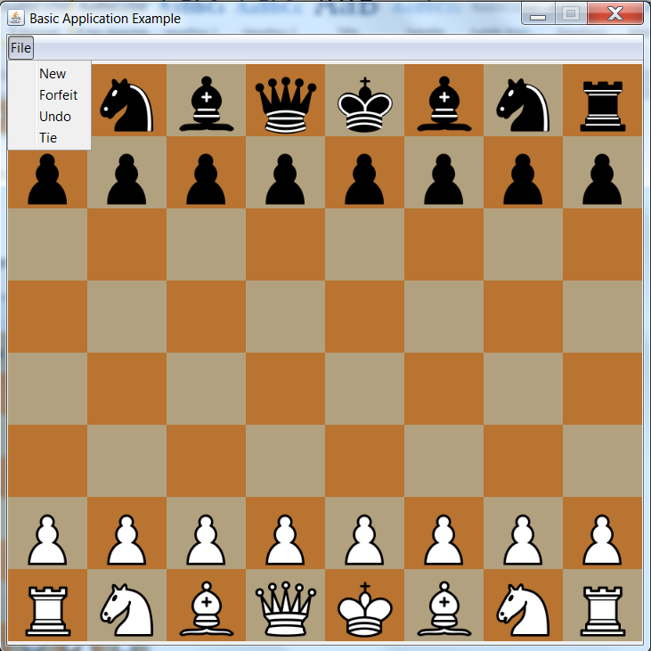

Step 2: Click on the file button in the menu on top. There will be 4 buttons, New, Forfeit, Undo, and Tie.

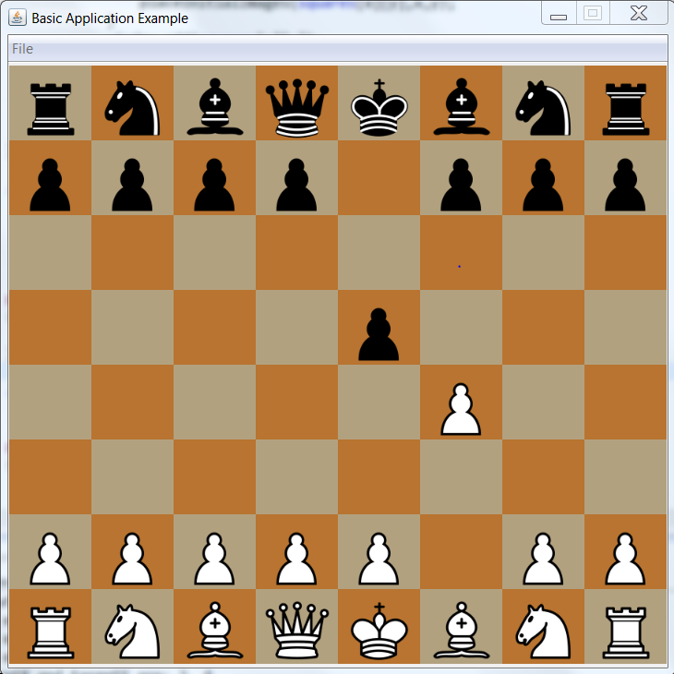

Step 3: Move the pieces into these positions. Note that the white piece moves first and you are unable to do moves of pieces that are the same color.

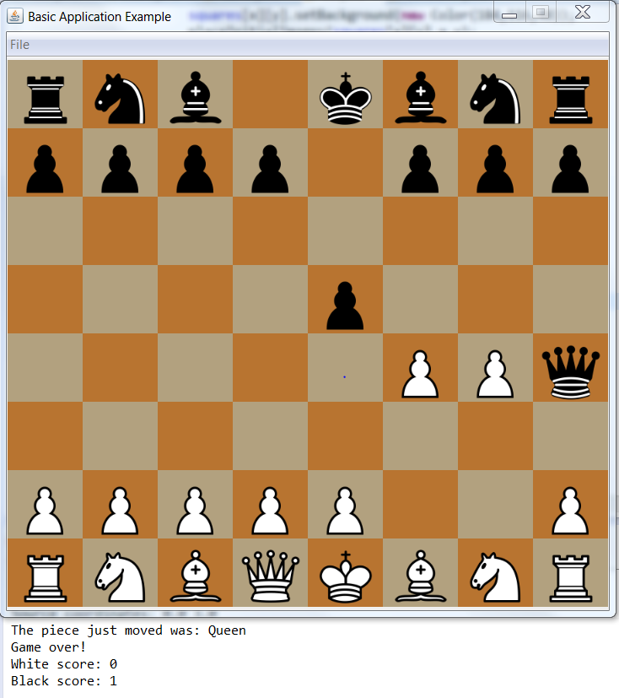

Step 4: Continue moving pieces until you achieve this position. Note that the console should print the game is over, and print the corresponding score.

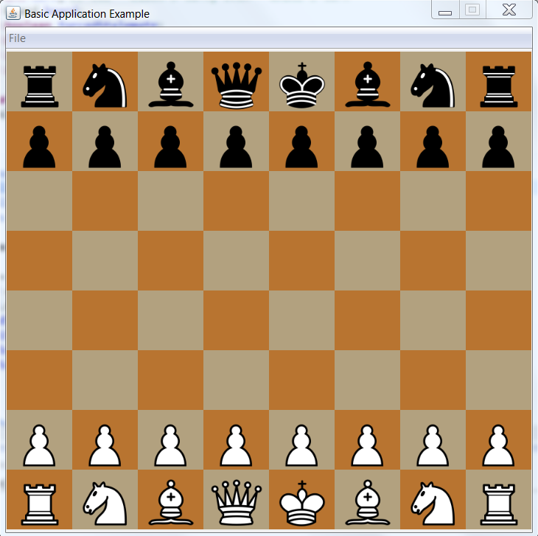

Step 5: Go to “File” and click “New”. The board should reset itself into this position.

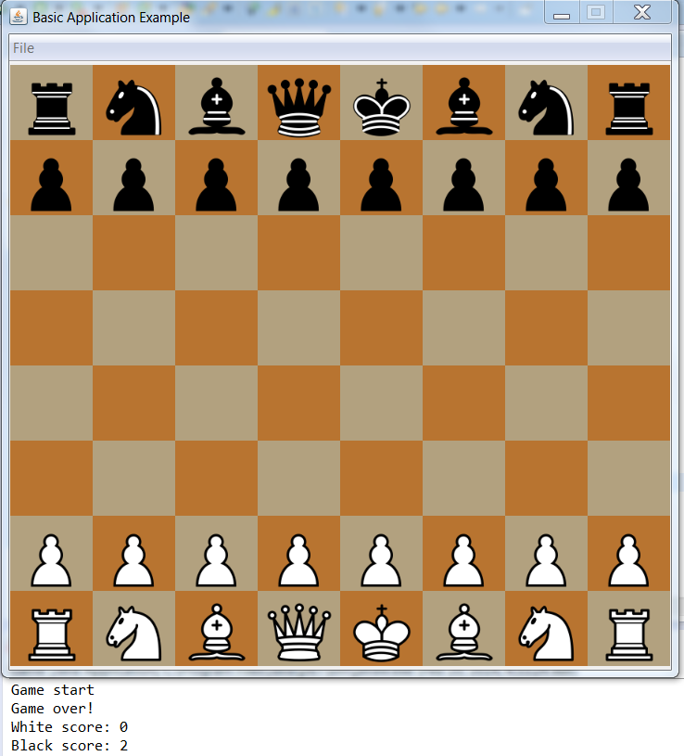

Step 6: Once again, go to “File” and click “Forfeit”. The console should now reflect the new score in the game.

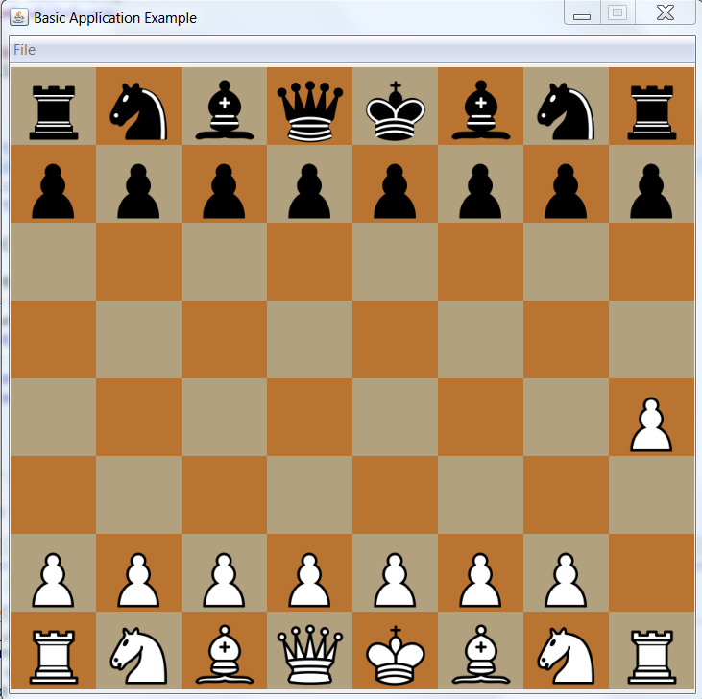

Step 7: Move the pawn as shown above, and then click “Undo” under the File tab. The end result should look like the right image.



Step 8: Go to file and click “Tie”. The Console should reflect no change in score, although the game will have finished.